**QA Analyst test**

The main objective of this exercise is to learn more about your profile as a QA Analyst. Therefore, our goal is to give you the freedom to develop each of the points in the way you consider appropriate, both in terms of detail and the tools to be used (unless otherwise specified in specific cases).

To submit your work, we ask you, preferably, to create a repository on GitHub otherwise, use another documentation tool and upload everything there! Organize it in the way that seems best to you. Once it's ready, send us the link and make sure it is public so that we can access it without any issues.

**Test Case Creation**

Access <https://sea-lion-app-7celq.ondigitalocean.app/> and perform a thorough navigation as much as possible.

After doing so, we invite you to generate the test cases that you believe are necessary according to the functionalities you find. You can use the tool that is most comfortable for you.

Once created, briefly explain which test cases you consider necessary to execute in a smoke testing of the application.

**Bug Reporting**

Find a bug in the application and report it in the way you consider appropriate.

Also, identify an improvement opportunity and report it as a task to be done in the future.

**APIs**

Taking into account the information from the APIs that you can extract from the browser inspector while navigating the app, develop and document backend test scenarios using Postman and, if possible, automate at least one scenario with the same tool.

The application does not have any authentication.

**Automation**

Select 3 test cases developed in the first step and generate a set of automated tests that include them, using Cypress/Selenium or any framework in which you feel comfortable.

Since the app is deployed on Heroku, the timeout times may be longer than the default. To change that, we suggest you refer to https://docs.cypress.io/guides/references/configuration#Runner-Specific-Overrides, which ultimately aims to modify the 'cypress.json' file generated in the root of your directory and expose something similar to the JSON shown on the site (the longer it is, the less chance of timeout you have).

**Mobile**

Given the following 3 screenshots of a wireless lighting device control application:

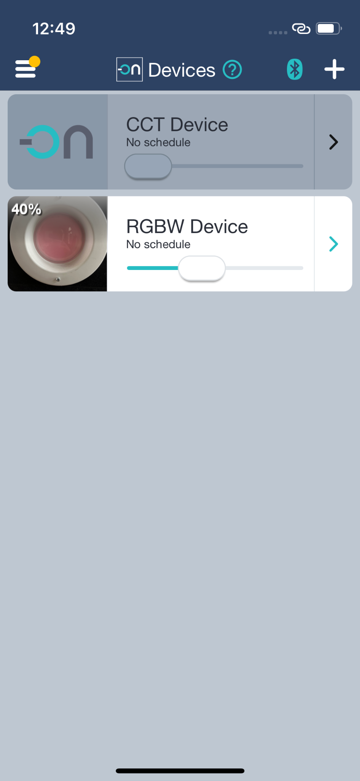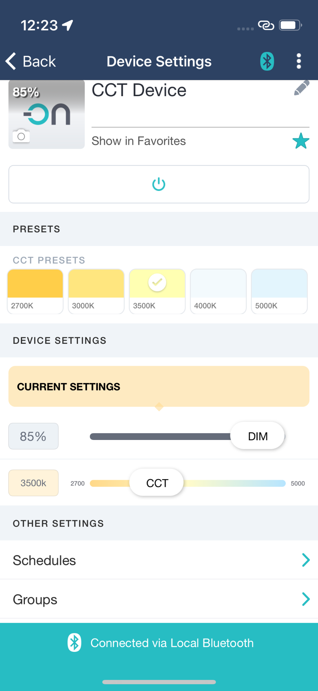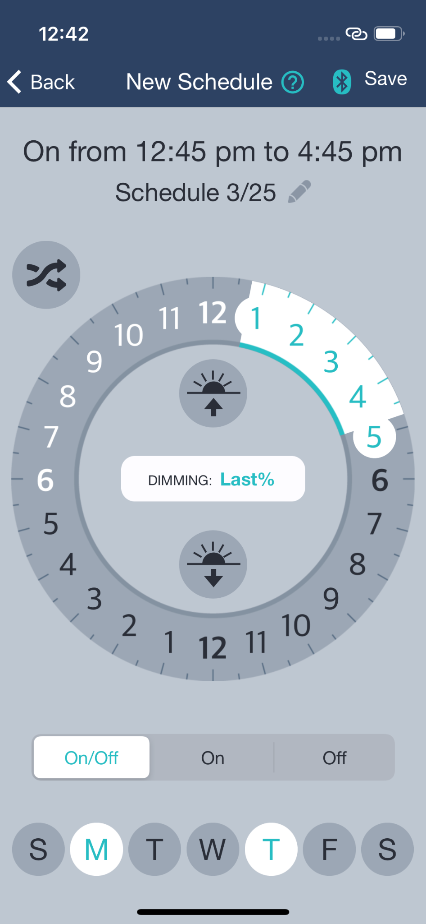

Create 3 test scenarios that you consider important with the highest level of detail possible, specifying the navigation flow as if they were for the user in the User Acceptance Testing (UAT) stage.